Setting Up SiteMaker for Testing

Introduction
This document describes the steps which are need to setup a SiteMaker installation for testing. It is intended to be used in conjunction with the regular deployment instructions. For the purposes of this document the location of the source checked out from StarTeam is referred to as SM_SOURCE_ROOT (this variable is not actually used, it’s just an placeholder).

Checkout and Modify Source
Check the SiteMaker and SMAdmin source out from StarTeam. Checkout the desired version of SMCustom (either the Generic version, or a customized one). Note: We should probably have a testing version of SMCustom with the changes below in it. Make these changes before proceeding with the installation:

- In the eomodel in SMCore, set the connection dictionary to point to the test database:

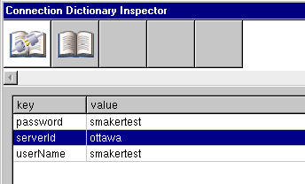

- If there is existing data in the database, drop the tables and primary key support when following the deployment instructions for creating the database:

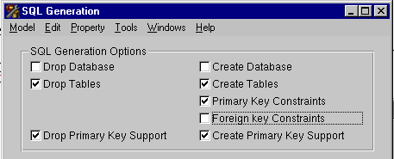

- Update the SiteMaker.plist file in the Resources suitcase of SMCore to make these changes:

  - Make sessions timeout quickly so that session timeout problems appear more readily:
SessionTimeOutInMinutes = "15";

  - Ensure we are testing deployment nor development functionality:
DevelopmentMode = "false";

  - Setup the root admin ID:
AdminID = "sitemaker1@global-village.net";
AdminPassword = "foo";

  - Setup the root unit name:
RootUnitName = "School of Hard Knocks";

  - Setup the "internal users" name:
UMichGroupName = "SoHK Users";

  - Setup the e-mail addresses for testing
FromAddress = "sitemaker1@global-village.net";
NewSiteRequestAddress = "chill@global-village.net";

  - Setup the URLs and paths for the test environment. The values below are only a suggestion. The actual values used will depend on the WebObjects adapter used and how the web server is reached (virtual host name etc.):
mainPageURL = "http://sitemaker.global-village.net/cgi-bin/WebObjects/sitemaker";
baseDirectActionURL = "sitemaker.global-village.net/";
directActionPath = "cgi-bin/WebObjects/sitemaker.woa/wa/";

  - Define any additional system administrators as they exist in the test plan. This just allows them to be system administrators, this does not create the users. User creation should be done as part of the test plan. Make sure you include the e-mail address from AdminID from above here.
sysadmins = (
"sitemaker1@global-village.net",
…
);

  - Define the Site Styles to be used for testing:
siteStyles = {…}
defaultStyle = "UMGeneric1";

Setup Testing e-mail Addresses
e-mail address aliases sitemaker1@global-village.net through sitemaker10@global-village.net have been created for testing. These need to be redirected to the account of whoever will be doing the testing.

Install the Application
Follow the deployment instructions.

Special handling for SMStyleTemplates?

Bootstrapping the system
- Start the SiteMaker application ONLY.
- Hit the application main page with a browser
- Click on the link to view the Directory of Sites. You will get a Session Restoration error this first time, but it should not happen after that.
- At this point, the database should be properly initialized.

*** Need to ensure uploaded files are placed in a clean directory.
*** Need to configure for SiteMaker Virtual Hosts testing

